LONGFORD MUNICIPAL DISTRICT

Corporate Affairs,
Please note venue of meeting- Aras an Chontae,
Council Chamber, Aras an Chontae, LONGFOIRT.
Great Water Street.
15th February 2017.

To: Each Member of Longford Municipal District.

Dear Member,

You are requested to attend Meeting of Longford Municipal District to be held in the Council Chamber, Aras an Chontae, Great Water Street, Longford on Wednesday, 22nd February 2017 as follows –

- 4.00 p.m. - Meeting of Municipal District to consider and approve
Schedule of Longford Municipal District Works – report enclosed

Yours sincerely,
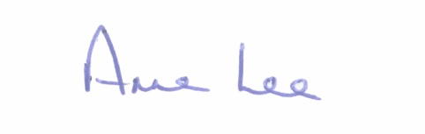

_______________
Anne Lee,
Meetings Administrator.

Encl.

